SIMATS ENGINEERING
ASSESSMENT TOOL 1
ARTIFICIAL INTELLIGENCE
Course Code: CSA1718

Student Name | M NIHANTH
Register Number | 192411241
Department | CSE
Date | 14-07-2026

Contents
1. Water Jug Problem
2. Mars Rover as an Intelligent Agent
3. Eight-Queens Problem
4. OLA Cab Booking Problem-Solving Agent
5. Uniform Cost Search for Logistics Network
Prepared according to the questions and rubric provided in Assessment Tool 1.

1. Water Jug Problem

Problem Understanding
Two unmarked jugs are available: a 4-gallon jug and a 3-gallon jug. The allowed operations are filling a jug, emptying a jug, and pouring water from one jug into the other. The objective is to obtain exactly 2 gallons in the 4-gallon jug.

State Representation
Represent a state as (x, y), where x is the amount of water in the 4-gallon jug and y is the amount in the 3-gallon jug.
Initial state: (0, 0) Goal state: (2, y)

Solution Process
Step | Action | 4-gallon jug | 3-gallon jug
1 | Start with both jugs empty | 0 | 0
2 | Fill the 3-gallon jug | 0 | 3
3 | Pour the 3-gallon jug into the 4-gallon jug | 3 | 0
4 | Fill the 3-gallon jug again | 3 | 3
5 | Pour into the 4-gallon jug until it becomes full | 4 | 2
6 | Empty the 4-gallon jug | 0 | 2
7 | Pour the remaining 2 gallons into the 4-gallon jug | 2 | 0

State Sequence and Final Result
(0,0) → (0,3) → (3,0) → (3,3) → (4,2) → (0,2) → (2,0)

Therefore, the 4-gallon jug contains exactly 2 gallons, and the goal is achieved.

2. Mars Rover as an Intelligent Agent
A Mars rover is an autonomous intelligent agent that senses the Martian environment, plans movements, avoids hazards, collects samples and sends scientific data to Earth.

i. Percepts of the Agent
- Images from navigation and scientific cameras
- Distance and location of rocks, craters and obstacles
- Soil and rock composition
- Temperature, pressure, wind and radiation levels
- Ground slope, terrain roughness and wheel slippage
- Current position, orientation and travelled distance
- Battery level, solar-energy availability and internal system temperature
- Communication signals and commands from Earth
- Health status of motors, sensors and scientific instruments

ii. Characterisation of the Operating Environment
Property | Characterisation | Reason
Observability | Partially observable | The rover cannot observe the entire environment at one time.
Determinism | Stochastic | Terrain, dust and wheel slip create uncertain outcomes.
Task structure | Sequential | A present action changes future states and available actions.
Change | Dynamic | Lighting, temperature, dust and terrain conditions can change.
State values | Mostly continuous | Position, speed, time and temperature vary continuously.
Agents | Mainly single-agent | The rover acts independently while receiving guidance from Earth.
Knowledge | Partially unknown | It may encounter unseen rocks, slopes and hazards.
Accessibility | Inaccessible | Complete and exact information about Mars is unavailable.

iii. Actions the Agent Can Take
- Move forward or backward; turn left or right; stop
- Choose another route and avoid obstacles
- Capture and transmit photographs
- Extend the robotic arm and drill into rocks
- Collect, store and analyse soil or rock samples
- Measure atmospheric and environmental conditions
- Receive instructions and transmit scientific data
- Recharge batteries or enter power-saving mode
- Diagnose faults and recover from minor failures

iv. Performance Evaluation
Performance Measure | Evaluation
Scientific value | Quality and number of useful samples and measurements collected.
Navigation accuracy | Ability to reach selected destinations safely.
Obstacle avoidance | Success in detecting and avoiding hazards.
Energy efficiency | Useful scientific work completed per unit of energy consumed.
Mission completion | Percentage of assigned objectives successfully completed.
Safety and reliability | Protection of wheels, instruments and communication systems.
Data quality | Accuracy and usefulness of images and scientific results.
Time efficiency | Completion of planned tasks within available mission time.
Communication efficiency | Successful transmission of data with minimal loss.
Energy Efficiency = Useful Scientific Work Completed / Energy Consumed

v. Most Suitable Agent Architecture
The most suitable design is a hybrid model-based, goal-based, utility-based and learning agent.
Component | Purpose
Model-based | Maintains an internal map of obstacles, visited areas, targets and safe routes.
Goal-based | Plans actions to reach scientific targets and complete mission objectives.
Utility-based | Balances scientific value, travel time, energy use and risk.
Learning | Improves navigation by learning from terrain images, wheel slips and previous outcomes.
Utility: U = w₁S − w₂E − w₃T − w₄R

Here, S is scientific value, E is energy consumption, T is travel time, R is risk, and the w values represent their importance. This hybrid design is suitable because the rover must operate autonomously under uncertainty while conserving energy and maximising scientific value.

3. Eight-Queens Problem
The task is to place eight queens on an 8 × 8 chessboard so that no two queens attack each other. Therefore, no two queens may share the same row, column or diagonal.

Problem Components
Component | Formulation
State space | A partial arrangement represented as [r₁, r₂, …, rₖ], where rᵢ is the row of the queen in column i.
Initial state | An empty board: [ ].
Actions | Place one queen in the next column in a row that is not attacked.
Transition model | Append a safe row to the current state.
Goal test | Eight queens are placed with no shared row, column or diagonal.
Path cost | Each placement has cost 1; every complete solution has total cost 8.

Safety Conditions
For a new queen at row r and column c, and an existing queen at row rᵢ and column cᵢ:
r ≠ rᵢ and |r − rᵢ| ≠ |c − cᵢ|

The first condition prevents a shared row. The second prevents a shared diagonal.

Search-Space Analysis
Without constraints, the search space is 8⁸ = 16,777,216 possible assignments. Restricting the board to one queen per row and column reduces it to 8! = 40,320 arrangements. Backtracking reduces the practical search space further by rejecting unsafe partial states immediately.

Suitable Search Strategy
Depth-First Search with Backtracking is suitable. Queens are placed one column at a time. When no safe position exists, the algorithm returns to the previous column and changes an earlier decision.
PROCEDURE SolveEightQueens
board[1..8] ← 0
IF PlaceQueen(board, 1) = TRUE THEN
PRINT board
ELSE
PRINT "No solution exists"
END IF
END PROCEDURE
FUNCTION PlaceQueen(board, column)
IF column > 8 THEN
RETURN TRUE
END IF
FOR row ← 1 TO 8 DO
IF IsSafe(board, row, column) = TRUE THEN
board[column] ← row
IF PlaceQueen(board, column + 1) = TRUE THEN
RETURN TRUE
END IF
board[column] ← 0
END IF
END FOR
RETURN FALSE
END FUNCTION
FUNCTION IsSafe(board, newRow, newColumn)
FOR oldColumn ← 1 TO newColumn - 1 DO
oldRow ← board[oldColumn]
IF oldRow = newRow THEN
RETURN FALSE
END IF
IF ABS(oldRow - newRow) =
ABS(oldColumn - newColumn) THEN
RETURN FALSE
END IF
END FOR
RETURN TRUE
END FUNCTION

One Valid Solution
[1, 5, 8, 6, 3, 7, 2, 4]

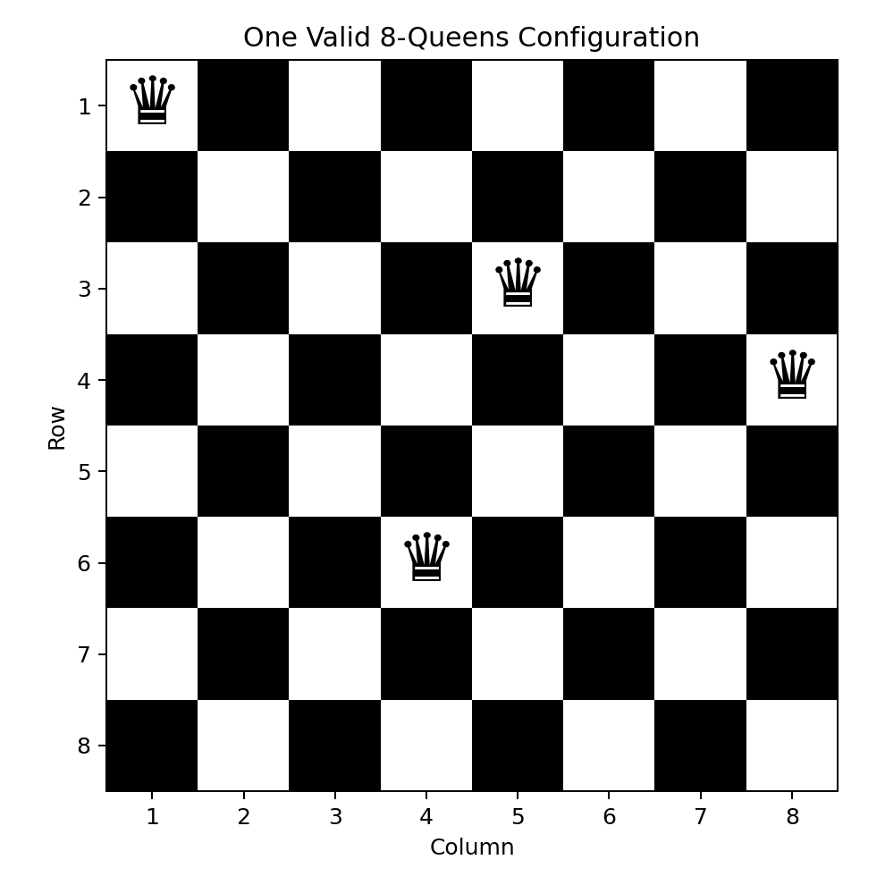
The displayed arrangement contains one queen in every row and column, and no two queens share a diagonal.

4. OLA Cab Booking Problem-Solving Agent

Problem Understanding
The customer provides a pickup location and destination. The mobile application must search for available cabs, compare cab types such as Micro, Mini, Sedan, Prime, Shared and SUV, and recommend a suitable option based on fare, comfort, waiting time and travel time.

Type of Agent
A goal-based and utility-based problem-solving agent is most suitable.
- The goal-based component ensures that the passenger reaches the destination.
- The utility-based component compares several valid cab options and selects the most beneficial one.
U(c) = w₁C + w₂R − w₃F − w₄W − w₅T

C = comfort, R = driver rating, F = fare, W = waiting time and T = travel time.

Problem Formulation
Element | Description
Initial state | Customer is at the pickup location and no cab is selected.
Goal state | Customer reaches the destination safely and conveniently.
State space | Locations, available cabs, drivers, routes, traffic, fare and estimated time.
Actions | Enter locations, select cab type, confirm/cancel booking, pay and track the trip.
Transition model | Searching → cab assigned → driver arriving → trip started → destination reached.
Path cost | A weighted combination of fare, travel time and waiting time.
Goal test | Current location equals destination and trip status is completed.
Cost = α(Fare) + β(Travel Time) + γ(Waiting Time)

Pseudocode
PROCEDURE BookOLACab
INPUT pickupLocation, destination
INPUT passengerCount, comfortPreference, maximumBudget
IF pickupLocation = destination THEN
PRINT "Pickup and destination cannot be the same"
STOP
END IF
routes ← FindRoutes(pickupLocation, destination)
IF routes is empty THEN
PRINT "No route is available"
STOP
END IF
bestRoute ← FindMinimumCostRoute(routes)
cabTypes ← {Micro, Mini, Sedan, Prime, Shared, SUV}
availableOptions ← empty list
FOR each cab IN cabTypes DO
IF CabIsAvailable(cab, pickupLocation) THEN
fare ← CalculateFare(cab, bestRoute)
waitingTime ← EstimateWaitingTime(cab)
utility ← CalculateUtility(cab, fare,
waitingTime, bestRoute.time)
IF fare ≤ maximumBudget AND
CabCapacity(cab) ≥ passengerCount THEN
ADD cab and utility TO availableOptions
END IF
END IF
END FOR
IF availableOptions is empty THEN
PRINT "No suitable cab is available"
STOP
END IF
SORT availableOptions BY utility IN descending order
DISPLAY availableOptions
INPUT selectedCab
IF CustomerConfirms(selectedCab) THEN
driver ← AssignNearestDriver(selectedCab)
ConfirmBooking(driver, selectedCab, bestRoute)
TrackTripUntilDestination()
ProcessPayment()
PRINT "Trip completed successfully"
ELSE
PRINT "Booking cancelled"
END IF
END PROCEDURE
This agent reaches the required destination while selecting the best combination of comfort, price, availability, driver rating and journey duration.

5. Uniform Cost Search for the Logistics Network
The objective is to identify the least-cost path from warehouse S to warehouse G. Uniform Cost Search expands the frontier node with the smallest cumulative path cost.
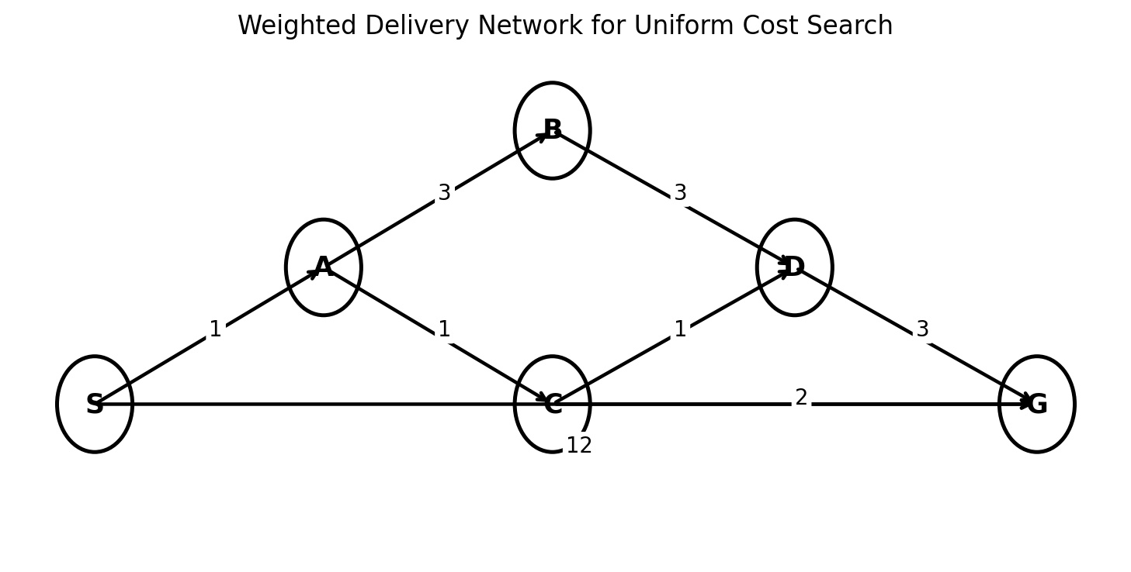

Given Route Costs
Route | Cost
S → A | 1
S → G | 12
A → B | 3
A → C | 1
B → D | 3
C → D | 1
C → G | 2
D → G | 3

Why UCS Is Suitable
UCS orders nodes by cumulative cost g(n). Because all route costs are positive, the algorithm is complete and optimal and will return the minimum-cost route.

Step-by-Step Expansion
Step | Node Expanded | Result | Priority Queue
1 | Expand S | Add A with cost 1 and G with cost 12. | [(A,1), (G,12)]
2 | Expand A | Add B with cost 4 and C with cost 2. | [(C,2), (B,4), (G,12)]
3 | Expand C | Add D with cost 3 and update G to cost 4. | [(D,3), (B,4), (G,4)]
4 | Expand D | Route to G costs 6, so retain existing G cost 4. | [(B,4), (G,4)]
5 | Expand remaining cost-4 nodes | B gives a more expensive route to D; G is then selected. | Goal reached

Path Comparison
Path | Total Cost
S → G | 12
S → A → C → G | 1 + 1 + 2 = 4
S → A → C → D → G | 1 + 1 + 1 + 3 = 6
S → A → B → D → G | 1 + 3 + 3 + 3 = 10
Minimum-cost path: S → A → C → G Total cost = 4

UCS Pseudocode
FUNCTION UniformCostSearch(start, goal)
priorityQueue ← empty priority queue
INSERT (start, cost = 0, path = [start])
bestCost[start] ← 0
WHILE priorityQueue is not empty DO
current ← REMOVE node with lowest cost
IF current.node = goal THEN
RETURN current.path, current.cost
END IF
FOR each neighbour of current.node DO
newCost ← current.cost +
EdgeCost(current.node, neighbour)
IF neighbour is not in bestCost OR
newCost < bestCost[neighbour] THEN
bestCost[neighbour] ← newCost
newPath ← current.path + neighbour
INSERT (neighbour, newCost, newPath)
INTO priorityQueue
END IF
END FOR
END WHILE
RETURN "No path exists"
END FUNCTION

Interpretation of Result
The direct route S → G costs 12 units, while the UCS-selected route costs only 4 units.
Cost saving = 12 − 4 = 8 units

Percentage reduction = ((12 − 4) / 12) × 100 = 66.67%

Therefore, the logistics company should use S → A → C → G. This route reduces the cost by approximately 66.67% compared with the direct route.

Overall Conclusion
- The Water Jug problem demonstrates state-space formulation and legal operators.
- The Mars Rover is best modelled using a hybrid intelligent-agent architecture.
- The Eight-Queens problem is efficiently solved using depth-first search with backtracking.
- OLA cab booking uses goal-based and utility-based reasoning to compare alternatives.
- Uniform Cost Search identifies S → A → C → G as the optimal logistics route with cost 4.

